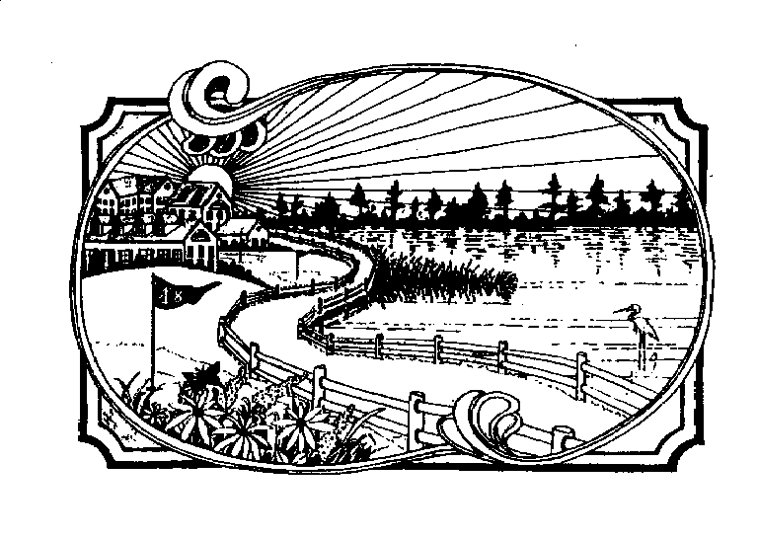

TOWNSHIP OF GALLOWAY
DEPARTMENT OF COMMUNITY DEVELOPMENT
PLANNING BOARD ZONING BOARD OF ADJUSTMENT
_______________________________________________________
300 E. JIMMIE LEEDS ROAD, GALLOWAY, NJ 08205
(609) 652-3700 EXT. 218 FAX: (609) 652-5259

AGENDA

ZONING BOARD OF ADJUSTMENTS
FEBRUARY 14, 2019
6:30 P.M.

This meeting has been canceled.
The next Zoning Board meeting will be held on
March 14, 2019
Thank you.

